**Chapter 2: Van der Waals forces alone are a weak design principle for transmembrane helix interaction stability**

This chapter was prepared for publication as:

Gilbert J. Loiseau and Alessandro Senes “Van der Waals forces alone are a weak design principle for transmembrane helix interaction stability” In preparation.

2.1 Abstract

Membrane protein folding occurs as a result of an equilibrium of biophysical forces. Polar and charged interactions can drive folding within the hydrophobic environment of the membrane. The stabilizing effects of sidechain packing on membrane protein folding were deduced in a variety of foundational bacteriorhodopsin studies, and sidechain packing as a driving force has been demonstrated through modern protein re-design of phospholamban. However, the extent at which packing can act as a driving force in general in membrane protein systems is not well understood. We investigate the impact of sidechain packing on membrane protein association by using computational design. By sampling dimer conformations from the PDB, we designed hundreds of sequences that self-associate. Structural characterization through mutations on these proteins suggests that packing is a weak driving force in a variety of membrane protein systems.

2.2 Introduction

Proper membrane protein folding is regulated by a distribution of stabilizing hydrogen bonds, weak polar interactions, and van der Waals (vdW) forces between the unfolded and folded states. Hydrogen bonding and polar interactions have been found to modestly stabilize both large protein complexes (Ben-Tal et al., 1997; Bowie, 2011; Mitchell & Price, 1990; Rose & Wolfenden, 1993; Tsemekhman et al., 2007) and association of smaller peptides such as glycophorin A (GpA) (MacKenzie et al., 1997; Smith et al., 2002). Mutations to key hydrogen bonding residues plays a role in promoting disease states such as cystic fibrosis (Partridge et al., 2004; Therien et al., 2001; Wehbi et al., 2008). Misfolding of membrane proteins has been found to be involved in several genetic diseases such as Parkinson’s and cancer (Gregersen et al., 2006; Sanders & Myers, 2004). Understanding how forces drive membrane protein folding is a critical task to further prevent disease. However, research is lacking on the contribution of vdW packing.

The contribution of vdW packing to membrane protein folding can be broken down into three distinct interactions: lipid-lipid packing, lipid-protein packing, and protein-protein packing. Protein-protein (or sidechain) packing is a technically feasible starting point because of the ability to manipulate sequences and determine changes in stability due to mutation. Previous research has demonstrated that disruption of packing within the core of bacteriorhodopsin destabilizes protein structure, suggesting that it is a necessary force for proteins to reach optimal stability (Faham et al., 2004; Joh et al., 2009). Additionally, a recent study using membrane protein design has shown that optimized sidechain packing can stabilize the folded state of phospholamban, demonstrating that packing can drive protein stability (Mravic et al., 2019). Although these studies suggest that sidechain packing plays a role in stabilizing membrane proteins, there has not been much investigation of the thermodynamic contribution of packing outside of individual structures.

Research using homodimerization as a model system has measured the contributions of both hydrogen bonding and weak polar interactions in the membrane, determining that these forces drive membrane protein folding (Johnson et al., 2007; Yano et al., 2002; Zhou et al., 2001). In this study, we investigate the effect of sidechain packing within a multitude of dimer structures. Using large-scale computational design on the most common dimeric backbone geometries found within the PDB, we designed thousands of homodimer sequences and characterized their propensity to associate with a complementary high-throughput method, sort-seq (Anderson, 2019). Using this simple and tractable model system, successfully designed dimers that associate, suggesting that sidechain packing is a weak driving force involved in TM association.

2.3 Results and Discussion

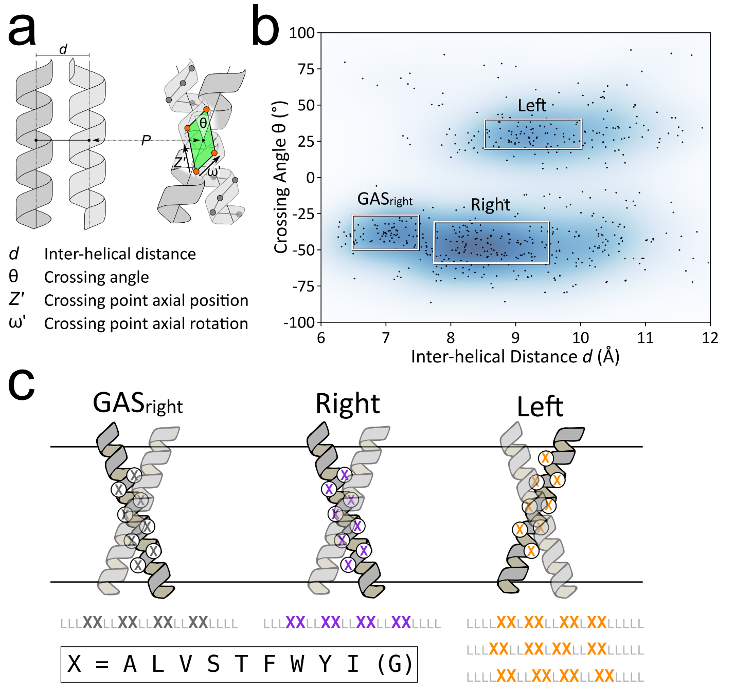2.3.1 Design strategy

**Figure 1** **Membrane protein dimer design.** **a)** Homodimer interfacial sequences are designed on straight helical structures placed at 4 geometric parameters: distance (d), angle (θ), axial rotation (ω), and Z-shift (Z). **b)** Helices within close contact were extracted from the Orientations of Proteins in membranes (OPM) in September 2019. The geometric terms were extracted and overlaid over the kernel density estimation of the membrane protein contact space. **c)** Interfaces for designs on poly-leucine backbones, where x is an interfacial position that can be designed using a library of the most prevalent amino acids in membrane proteins. Glycine is only used for GASright designs.

Our strategy for investigating whether pure packing can be a strong force for stabilizing helix-helix interaction in membrane proteins was to choose a wide variety of commonly found inter-helical geometries and design their interfaces with hydrophobic side chains, producing different levels of optimal packing. The designed interfaces were limited to the hydrophobic amino acids most commonly found in membrane proteins (A, V, F, W, L, I, S, T and Y) (Liu et al., 2002). For variety, we chose to include Ser, Thr, and Tyr in the set of amino acids since they are common in membrane proteins (> 4%, Fig. S2). These amino acids contain a hydroxyl group and could potentially for inter-helical hydrogen bonds. However, these Ser and Thr have tendency to satisfy their potential by forming intra-helical hydrogen bonds with carbonyl groups at i-3 and i-4 (Bower et al., 1997). Tyr is an amino acid that has a tendency to be enriched in the membrane head-group region and it has a tendency to “snorkel”, and thus expose its η-hydroxyl group to water and polar groups in the head-group region (Liang & Tamm, 2016). These amino acids are thus compatible with a helix-helix interface mediated primarily by non-polar interactions. We chose not to include Gly because it is the central amino acid in the interface of the strong GASright motifs, to prevent the accidental occurrence of GASright capable dimers (Fig. 1b). All non-interfacial positions were standardized to Leu.

To produce the backbones for the designs, we selected the most common regions of helix-helix interaction geometry, under the assumption that these would be the most favorable regions for protein design. To identify these regions, we analyzed the geometry of all pairs of interacting helices found in known membrane protein structures, using a database of 1541 membrane protein structures from Orientations of Proteins in Membranes, filtered by sequence similarity from the PDB (Lomize et al., 2006; Steinegger & Söding, 2017). Any two helices in close contact in the structures were considered as an individual helical pair and the conformational parameters of each pair were computed (i.e., the crossing angle θ, the inter-helical distance *d*, the axial rotation of each helix ω, and the displacement in along the helical axis or *Z*-shift, see Fig. 1a and Methods). Although similar analyses were performed previously (Senes et al., 2001; Walters & DeGrado, 2006), we restricted the analysis to consider only the subset of helical pairs that interact through segments that have regular α-helix conformation, since the inclusion of segments that contain kinks, curvature, 310 helix and other deviations from standard α-helix, introduces errors in the estimation of the helical parameters (i.e. θ, *d*, ω, *Z*) of the pairs.

Fig. 1b illustrates the resulting helix-helix interaction landscape for parallel helical pairs (i.e. the pairs whose N-termini are on the same side of the membrane), plotted as a scatterplot of the crossing angle θ and interhelical distance *d*. Two major high-density regions that are suitable for vdW-based protein design were identified. In the left-handed region (positive crossing angle θ), the helical pairs are found to interact most frequently in the range between approximately 8.5 to 10 Å of inter-helical distance and a 20 to 40° crossing angle (a region that we call “Left”, highlighted as a box in Fig. 1b). The right-handed region presents a broader range of distances from 6.5 to over 10 Å of distance and crossing angles between -30 and -60°. We selected the maximum density region with inter-helical distance between 7.75 and 9.5 Å and a -30 to -60° crossing angle (“Right” box) as the second source of backbones.

The section of the right-handed region (θ = -25 to -55°) with the closest inter-helical distance (*d* = 6.5 to 7.5 Å) corresponds to the GASright motif, a well-know helix-helix dimerization and interaction motif (Mueller et al., 2014; Russ & Engelman, 2000). It has a sequence signature of small amino acids (Gly, Ala, Ser) at the dimer interface, forming its characteristic GxxxG and similar sequence motifs (GxxxA, SxxxG, etc.). These small amino acids allow for the short inter-helical distance that brings the helical backbones in contact, which results in the formation of characteristic networks of inter-helical weak hydrogen bonds between between activated Cα–H carbon donors and backbone carbonyl acceptor groups on the opposing helix (Cα–H∙∙∙O=C hydrogen bonds) (Senes et al., 2001). We previously showed that these networks of Cα–H are major contributor to the stability of GASright along with vdW interactions (Anderson et al., 2017). Since GASright can form strong dimers, we used designs in this region as a positive control in our procedure along with the vdW only design based on the “Left” and “Right” regions. The set of amino acids used for the design of the interfaces of GASright designs included Gly in addition to the other 9 amino acids used for the Left and Right region designs.

2.3.2 Selection of backbones and Computational Design Strategy

Within the boundaries of the three regions of Fig. 1b, we selected a total of 10000 starting backbones with crossing angle and inter-helical distance randomly assigned within their boundaries. Since no specific dependency was identified for the axial rotation ω, and the *Z* displacement on the crossing angle and inter-helical distance, these two parameters were also assigned randomly (Fig. S7-S9). In creating these constructs we followed an approach used previously in a TOXGREEN study (Anderson et al., 2017). The designs we based on a 21 amino acid hydrophobic segment, with the crossing point between the two monomers placed near the middle of the membrane. For each dimer, only 8 positions at the helix-helix interface were set as variable for the design. All non-interfacial positions of the backbone were standardized to Leucine. This standardization reduces variability in hydrophobicity, which helps obtaining consistent expression and insertion into the membrane of the TOXGREEN constructs. The poly-Leu backbone was used because this sequence has low propensity for association in TOXCAT based assays, reducing the risk of non-specific association outside of our designed interface (Zhou et al., 2000; Zhou et al., 2001; Ruan et al., 2003).

The pattern of variable and fixed position used for the constructs is illustrated in Fig. 1c. For the GASright region, we adopted the typical pattern that spaces two interfacial positions (x) with two fixed positions (L), resulting in a LLL**xx**LL**xx**LL**xx**LL**xx**LLLL pattern (Anderson et al., 2017; Mueller et al., 2014; Russ & Engelman, 2000). The same interface was applied to the Right region designs, which has geometry similar to GASright outside of a larger inter-helical distance. In the Left region, the interfacial positions follows the typical L**xx**LL**x**L heptad repeat that is typical in leucine zippers, knobs-into-holes, and coiled coils (Ash et al., 2004; Bornberg-Bauer et al., 1998; Walshaw & Woolfson, 2003). However, the specific registry of this pattern is dependent on the Z-shift and axial rotation coordinate of the dimer (Fig. S10, Methods). For this reason three different interfacial patterns, all consisting of 8 variable positions, were adopted for dimeric designs in this region (Fig. 1c).

The protein design was based on a Monte Carlo procedure that included an initial fixed backbone design, followed by an iterative local backbone refinement using the resulting design sequence (Huang et al., 2022; Kuhlman et al., 2003; Kulp et al., 2012; Nash et al., 2015; Senes, 2011) (see Methods). As in our previous GASright prediction and design studies (Anderson et al., 2017; Mueller et al., 2014), each protein was evaluated using a computational energy score composed of a vdW function (MacKerell et al., 1998), hydrogen bonding (Krivov et al., 2009), and the IMM1 implicit membrane solvation (Lazaridis, 2003).

To control in part for the possibility that some of the constructs would associate through a different interface than their design, we designed mutations at positions expected to disrupt association of the given structure. For each of these designs, an interfacial position was mutated either small-to-large (isoleucine) or large-to-small (alanine) (Fig. 2a). The isoleucine mutants were designed to create significant clashes within the structure (“Clash mutants”), whereas the alanine mutations (”Large→Ala”) were designed to produce a significant reduction of packing at the helix-helix interface. Both Clash and Large→Ala mutants were expected to decrease association, with Clash mutants expected to result in drastic decreases as in previous studies (Khadria et al., 2014; LaPointe et al., 2013; Lawrie et al., 2010; Wei et al., 2011, 2013).

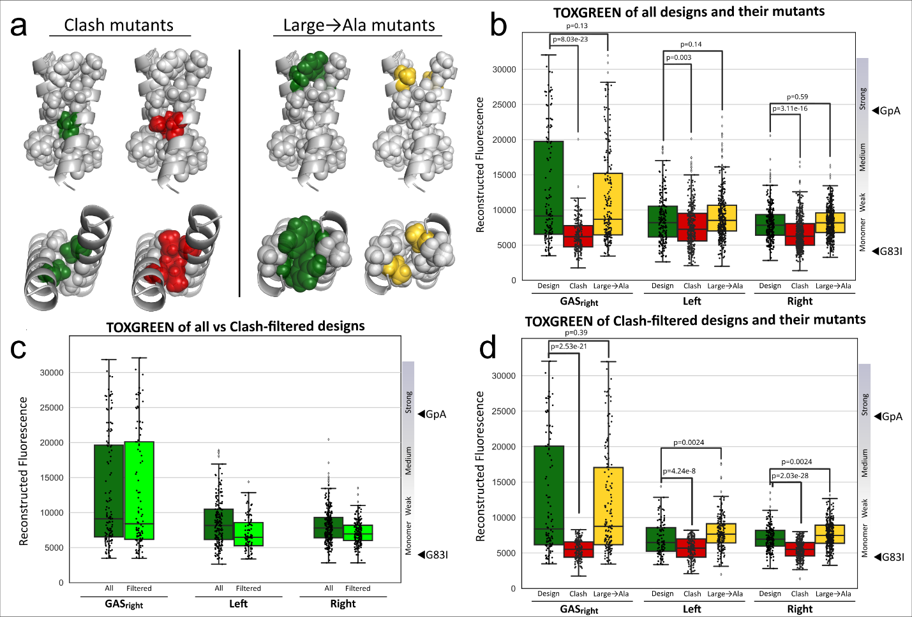2.3.3 Experimental determination of dimerization propensities

**Figure 2 Using mutants to validate designed sequences. a)** Mutations made to each WT design. Clash mutants result in atoms from one helix overlapping with atoms from the other helix, Void mutants result in pockets at the interface lacking atoms. **b-d)** Box and whisker plots separate the data by designating the lowest 25% and highest 25% of the data as whiskers outside of the box. Outliers are represented as diamonds outside of the range of the box and whisker plot. p-values determining the significant difference between design fluorescence and mutant fluorescence in b and d are shown over the corresponding boxplot. The WT (dark green) fluorescence distribution is compared to the fluorescence distributions of their corresponding clash (red) and void (orange) mutants in all data (**b**)and clash filtered (**d**). Panel **c** compares the clash filtered dataset of designs (light green) to all designs found in the sort-seq data (dark green).

We selected 1045 design sequences with a range of both structure and stability. The propensity for dimerization of these sequences and their mutants was assessed in the *Escherichia coli* membrane using the high throughput TOXGREEN sort-seq assay (Anderson, 2019). TOXGREEN (Armstrong & Senes, 2016) is the GFP-based version of TOXCAT, a widely used *in vivo* reporter assay that is sensitive to the relative association of TM dimers in a biological membrane. It is based on a chimeric protein in which the TM domain of interest is fused to the ToxR transcriptional activator. Dimerization of these constructs in the inner membrane promotes allows for ToxR binding to a specific promoter, resulting in the expression of chloramphenicol acetyltransferase (CAT, in TOXCAT) of GFP (in TOXGREEN). Quantification of these reporter proteins provides an indication of a TM domain’s propensity for oligomerization. We recently demonstrated that the TOXCAT signal of a series of GASright dimers based on a similar standardized poly-Leu backbone correlates well with their thermodynamic stability measured *in vitro* (Díaz Vázquez et al., 2023).

The recent development of a high-throughput TOXGREEN assay based on sort-seq (Anderson, 2019) allows for the measurement of thousands of constructs simultaneously. The assay utilizes a fluorescent activated cell sorting (FACS) to separate cells based on their GFP expression in bins. The relative frequency of a construct in the bins is then measured using next generation sequencing (NGS) and this profile is used to reconstruct the GFP fluorescence of each individual construct (Anderson, 2019).

2.3.4 The van der Waals-based designs are weak in comparison to GASright

The NGS analysis of the FACS fractions recovered 91% of the designed sequences (Fig. S3 and S4). After removing 241 constructs that do not grow in maltose media (suggesting that these constructs may have poor membrane insertion), we obtained a reconstructed TOXGREEN fluorescence signal for a total of 613 designs and their respective mutants (138 GASright, 198 Left and 277 Right). Fig. 2b shows the reconstructed GFP fluorescence distribution of the designs in the three regions (dark green) and their Clash (red) and Large→Ala mutants (orange). As a reference, the fluorescence of the two classic controls is indicated, the strong dimer glycophorin A (GpA) and its monomeric G83I variants.

It is notable that the fluorescence of the designs within the GASright region spans a larger range than both the Left and Right designs, including constructs with fluorescence comparable or greater than the strong GpA dimer, confirming the propensity of GASright for strong self-association. In contrast, the majority of the designs in the Left and Right regions appear monomeric or have a weak propensity to oligomerize. For example, approximately 40% of the GASright designs have a reconstructed fluorescence above 60% of the GpA standard (14,500 fluorescent units in the figure), compared to only 8% and 4% of the Left and Right designs. These data suggests that GASright is a motif that is highly designable for stability, whereas the sequences in the Right and Left region are much weaker. In turn, this suggests that, at least in the conditions tested, vdW packing is not a strong driver for dimerization, and thus that the network of weak hydrogen bonds that characterizes the interaction interface of GASright plays an important role for the stability of this common motif. It is however notable that even in the Right and Left regions, a small number of sequences are present whose TOXGREEN signals rise to the level corresponding to moderate dimerization propensity.

Fig. 2b shows the reconstructed TOXGREEN fluorescence of the Clash (red) and Large→Ala (orange) controls side by side with the original design (green). For the GASright designs, the introduction of clashing mutations result in a dramatic decrease in the distribution of fluorescence. Since these mutations were designed to be incompatible with their structural model, the results are consistent with the assumption that a majority of these constructs associate according to their designed interface. The reconstructed fluorescence distribution observed for the Clash mutants of the Left and Right design regions is less dramatic (as expected because these constructs already contain a large fraction of constructs that are monomeric or weakly dimeric) but statistically significant. This suggest the positions involved participate in the predicted interface also in a significant fractions of the Left and Right constructs.

Surprisingly, the set of Large→Ala mutants do not show a general decrease in fluorescence for any of the design regions. A small but not statistically significant decrease is observed for the designs in the GASright region, whereas the mutants in the Right and Left region show a small increase (also not significant). These mutants consist of individual Ala substitutions of larger (generally F, L, Y, and I) that were designed to reduce the amount of packing by a small amount (Fig. S5 and S6), although they do not generally create cavities, given the nature of the long and narrow nature of the helix-helix interface. Large-to-small mutations are often well tolerated in mutagenesis of single pass TM dimers but they can reduce dimerization (Doura & Fleming, 2004; Fleming & Engelman, 2001; Howitt et al., 1996; Metcalf et al., 2007; Mingarro et al., 1996). For this reason we hypothesized that we would observe a shift of the fluorescence distribution. It is possible that the design procedure does not have sufficient precision for producing effect from small alterations of packing that are measurable with TOXGREEN, if the changes in dimerization propensity are small.

2.3.5 A mutation-validated subset confirms that vdW-based designs are weak

We used the Clash mutations to create a set of validated constructs that behave consistently with the predicted interface. To retain a design in this filtered dataset, we imposed that all of its Clash mutants are in the monomeric range using a stringent threshold as the criterion (defined as below 35% GpA TOXGREEN signal). The selection resulted in a dataset that included 384 of the original 1045 designs (37%).

Fig. 2c shows the distribution of reconstructed TOXGREEN signal of the Clash-filtered dataset, compared to all designs. The distribution does not change for the GASright designs, which retains a wide range of dimerization propensities, including constructs with fluorescent signals comparable to the strong GpA dimer. Conversely, we observe a significant reduction of fluorescence for the designs based on vdW of the Right and Left regions. This data may indicate that a substantial number of designs in these region associate through a different interface than the one designed. Fig. 2d compares the dimerization propensity of the mutants of the Clash-filtered designs. The Clash mutants of all designs are below 35% GpA (corresponding to 8350 reconstructed fluorescence), otherwise they would have been discarded. For the GASright set, the distribution of fluorescence of the Large→Ala mutants remains similar to the distribution of the original designs, as it was for the unfiltered set. In the Left and Right regions, we observed a small but statistically significant overall apparent stabilization of the Large→Ala mutants relative to the original designs. We speculate that Ala residues may slightly favor random weak association over larger amino acids.

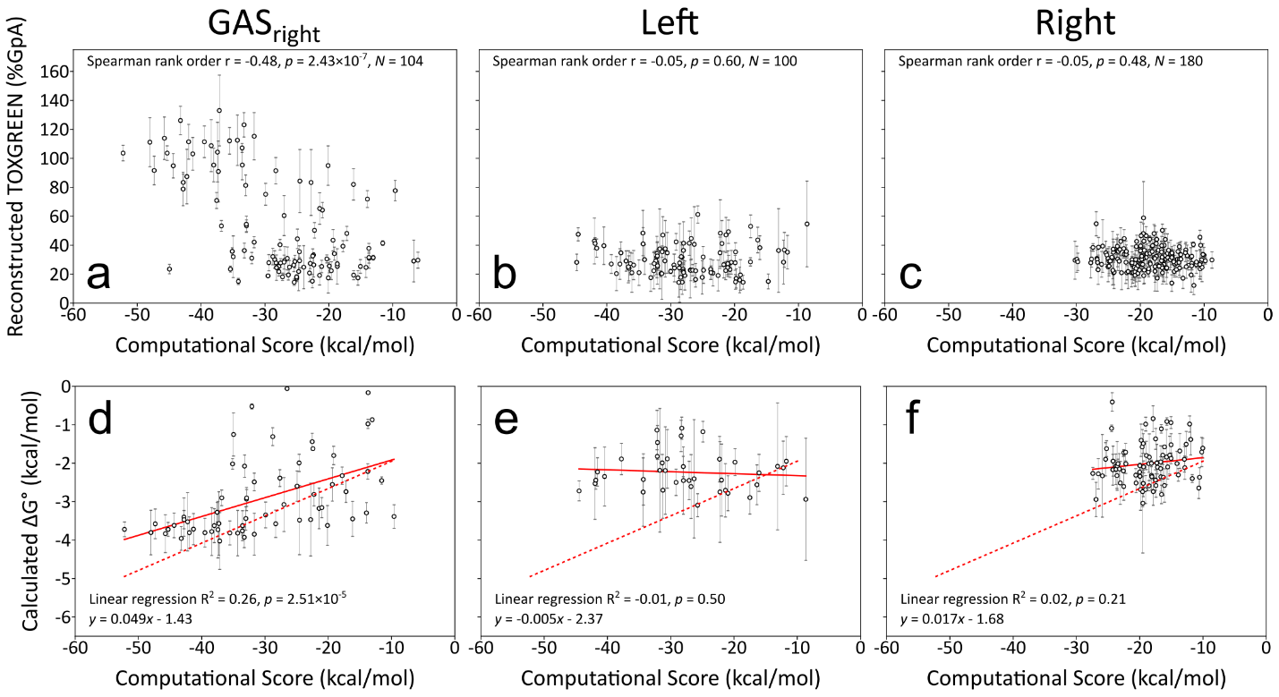2.3.6 GASright designs follow a previous energetic model of association

**Figure 3 Computational score vs dimerization propensity. a)** Design energy score plotted vs dimerization propensity in %GpA (a-c) and calculated ΔG (d-f). Spearman rank order correlation shows significance with computational score in GASright, but not other design regions. Dimerization propensity was converted to biophysical ΔG using methods from an *in vitro* FRET studying GASright association (Díaz Vázquez et al., 2023).

After experimentally determining the propensities of the three groups of Clash-filtered designs, we compared them to their computational energies (Tables ST1-3). Fig. 3a-c show scatterplots of the fluorescence of the designs against our energy score for each region. In a previous structure-based analysis of computationally predicted GASright dimers, we showed they followed a simple model of association in which a combination of Cα-H hydrogen bonding and vdW packing modulates their stability (Anderson et al., 2017). We found a similar proportionality between TOXGREEN dimerization propensity and computational score for this motif (Fig. 3a *p*=2.43×10-7, using Spearman Rank Order statistics because the TOXGREEN signal is not expected to be linearly dependent on dimerization free energy). Conversely, there is no notable correlation found for the Left (Fig. 3b) and Right (Fig. 3c) regions. Since the dimerization propensity of these designs populates only the monomeric and weakly dimeric ranges of TOXGREEN signal, it is not possible to assess whether the design would follow a similar trend against the computational energetics (which, in their case, would be based primarily on vdW and a solvation term, since these constructs are design not to form inter-helical hydrogen bonds).

2.3.7 Conversion of TOXGREEN signals to theoretical association free energies

In the final step of our analysis, we applied a conversion factor that enabled us to estimate the free energy of association of constructs from their TOXGREEN signal. The conversion is based on a recent study that found good agreement between the TOXGREEN dimerization propensities and the ΔG° of association of a series of poly-Leu GASright dimers measured in a decyl-β-maltopyranoside detergent environment using FRET (Díaz Vázquez et al., 2023). Once again, we found that there is a statistically significant linear correlation between the computational energy score of the GASright designs and their calculated Δ*G*° of association (Fig. 3d). The linear regression fit obtained here (*y* = 0.049*x* – 1.43, solid line, where *y* is the calculated Δ*G*° and *x* is the computational score) is similar to the original model of Diaz Vazquez (*y* = 0.076*x* – 1.33, dashed line), indicating that the large set of GASright designs of the present analysis behaves consistently with the previous set. As before, no correlation was found for the two sets of vdW-based designs (Fig. 3e and f). It should be noted that the fact that these designs only populate a small window in the low stability range prevent us to assess whether the energetic model would apply to these constructs.

2.4 Conclusion

We have performed a high-throughput analysis of transmembrane helix association to attempt to address the question of what extent vdW interactions can, as a design element, provide stability in membrane protein oligomerization and folding. The approach we took consists of a large-scale exploration of hundreds of dimers whose interfaces were designed to be mediated only by packing of non-polar side chains. These dimers were created to cover the entire geometric ranges of two common regions for helix-helix interaction, one characterized by left-handed crossing angles and the other in the right-handed region. As a comparison and control, we also designed hundreds of GASright dimers, a motif whose stability is also dependent on hydrogen bonding contributions.

The design is based on a simple energy score that consists of a vdW term, hydrogen bonding and the Lazaridis IMM1 implicit solvation. This energy score was successful at predicting the structure and energetics of a smaller subset of 26 GASright dimer before (Anderson et al., 2017; Díaz Vázquez et al., 2023). Those studies indicated that GASright dimerization is promoted by the combination of vdW interactions and the network of backbone-to-backbone Cα-H hydrogen bonds that characterizes the motif. The vdW component represented the largest contributor of the energetic model (by about a factor of 2 over hydrogen bonding, even when the desolvation cost was considered) (Anderson et al., 2017). This suggested that in the absence of inter-helical hydrogen bonding, vdW forces would be sufficient to produce rather stable transmembrane dimers. Our experimental data suggest that this is not the case since the majority of the vdW-based designs are monomeric or weakly oligomeric at best.

A possibility is that the procedure for designing the helical dimer is somehow more effective when applied to GASright configurations. In all three cases, we selected the most common regions of backbone space (and thus presumably the most conductive to stability) and applied the same design approach based on a series cycles of side chain optimization and local backbone geometry optimization, with the same energetic score. Alternatively, a more likely possibility is that the contributions of the vdW interactions in GASright association are over-estimated by our model. Finally, it may be possible that vdW forces and hydrogen bonding work cooperatively in GASright dimers, possibly at the expense of some of the entropic costs of dimer association, which are not considered in our rigid body model.

Overall, the data confirms that GASright, with its combination of packing and weak hydrogen bonding is indeed a special configuration for designing stable transmembrane helical pairs. It also suggests that vdW packing alone is not a strong enough force for designing strong dimers. It should be noted that among the designs in the Left and Right regions there are instances of designs that appear to rise to the level of moderately stable dimers (over 60% of GpA TOXGREEN signal), although most of them were removed by our stringent Clash-filtering procedure. Assessing those dimers individually (measuring their individual TOXGREEN signal, controlling for their expression and validating their conformation by extensive mutagenesis) would be laborious and it is outside of the scope of this work. However, future studies could address the possibility that, when fully optimized, packing of non-polar side chains leads to biologically significant stability.

2.5 Methods

2.5.1 Membrane protein helical pair extraction

We developed a program in MSL that extracts helical pairs from PDBs from OPM. To ensure that we don’t extract redundant helical pairs, the MP structures from OPM were trimmed by sequence similarity. Only unique structures with less than 30% sequence similarity (Steinegger & Söding, 2017) were analyzed. We first identify the top and bottom z-axes of the membrane in the OPM structure. The segments of the protein within the membrane are then assessed for their helical nature. Cartesian points for quadruplets of Cα carbons are then assessed for their helical nature. The height (1.25-1.75Å), twist (90-110°), and radius (2.12-2.42Å) are measured, with loose restrictions against the ideal values (1.5Å, 100°, 2.27Å) for each parameter. Helical segments composed of at least 13 AAs in length are extracted as individual helices, and the distance is measured between Cα carbons on each unique helical pair. Any two helices with at least 3 Cα carbons within 9Å of each other are extracted as an individual helical pair. The crossing angles and distances between these pairs are plotted on Fig. 1b.

2.5.2 Computational Sequence Design

The algorithm designs an interfacial sequence along a given poly-Leu backbone geometry. Using a Monte Carlo sequence optimization, an interfacial position is switched to a random amino acid most prevalently found in membrane protein sequences. The side chain mobility was modeled using the energy based conformer library, with interfacial side chains given higher mobility than non-interfacial (Subramaniam & Senes, 2012). To ensure that these designed sequences are membrane sequences, we developed a sequence entropy term. The sequence entropy term evaluates the current interface as it’s likelihood to occur in membrane protein sequences, and converts this likelihood to an energy applied during the sequence search. Energetics for the dimer were calculated using the CHARMM22 van der Waals function, the IMM1 membrane implicit solvation term, and the hydrogen bonding function SCWRL4. To estimate the free energy of the sequences during the search, we typically calculate the energy of a monomeric helix with the same sequence and subtract it from the dimer energy made of only these energetic terms.







We found that computing the monomer energy created a bottleneck during our sequence search. To reduce computational time, we developed an energy term that estimates the monomer energy for each designed sequence. This baseline monomer energy was determined by measuring the CHARMM_VDW, IMM1, and SCWRL4_HBOND energies for individual amino acids on a monomeric helix. The self (single AA) and pair (two AAs) energies were computed for 10000 random sequences and averaged. We found that there was a strong correlation between the computed monomer energy and this baseline monomer energy and utilized this energy during our sequence search. The baseline monomer energy and the sequence entropy are subtracted from the dimer energy to find the sequence with the most stable energy during the sequence search.



After the sequence is designed for the geometry, the structure undergoes Monte Carlo backbone optimization cycles where all parameters (distance, z-shift, axial rotation, and crossing angle) are varied. The final energy from backbone optimization is used to assess our designed constructs against their dimerization propensity. The total energy for the refined structure is used as the acceptance criteria, with the BASELINE_MONOMER energy being replaced by the computed monomer energy and the SEQUENCE_ENTROPY term no longer applied:



These energies are used to evaluate our sequences against their dimerization propensity determined in sort-seq.

2.5.3 Sequence Entropy

We developed a sequence entropy term that outputs an energy based on how similar a sequence is to the composition of natural membrane protein sequences. Previous studies have determined the amino acid composition of membrane proteins (Liu et al., 2002), but we chose to evaluate the composition of amino acids found in our helical pair TMs (Fig. S2). We first removed all amino acids that were represented less than 2% (C, P, H). We then trimmed the amino acid pool for amino acids likely to form disulfide bonds (M), hydrogen bonds (N, D, Q, E) except for a few that were well represented (S, T, Y), and charged interactions (K, R), leaving us with a pool of 10 amino acids for design (Fig. S2). To convert the frequency of AAs in a membrane sequence to an energy term, we utilized the following equation based on the Boltzmann entropy formula:



where R is the gas constant and T is temperature defaulted to 298K (RT = 0.592). To compute the sequence entropy, we calculated the probability that the sequence occurs in membrane. First, the number of each AA (AA1, AA2, etc.) is counted within the sequence. Using these values, we calculated the number of possible permutations for the sequence. This is determined using the following equation:

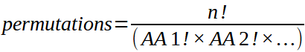

where n is the number of positions, which is divided by the factorial for #AA in the sequence multiplied, or the total number of combinations possible. The probability is computed using the frequency of each AA in membrane protein sequences (freqAA) to the power of the number of each AA in the sequence multiplied by the permutations:



This probability is inserted into the sequence entropy equation, returning a value that can be applied as an energy term during the sequence search.

2.5.4 Left-Handed Interfaces

During visual inspection of our randomized backbone geometries, we found that left-handed dimers were able to accommodate multiple interfaces. Interfaces differ based on the input axial rotation and z-shift (Fig. S10). LLL**xx**LL**xx**L**xx**LL**xx**LLILI: 0-40° axial rotation and 1-6Å z-shift (left stripe). LLLL**xx**L**xx**LL**xx**L**xx**LLILI: 30-90° axial rotation and 0-6Å z-shift (middle stripe). LLLL**xx**LL**xx**L**xx**LL**xx**LILI: 80-100° axial rotation and 0-2Å z-Shift (right stripe).

2.5.5 Cloning for bacterial cell expression

Sequences were ordered as an oligo pool from Twist Biosciences. Individual segments were amplified using qPCR (Roche KAPA SYBR Fast). Segments were digested using restriction enzymes NheI-HF and DpnII. TOXGREEN vector was digested in preparation for ligation using restriction enzymes NheI-HF, BamHI-HF, and CIP. Plasmids were assembled by incubating segment DNA with TOXGREEN vector in a 1:10 backbone:insert ratio with ElectroLigase for 2 hours at room temperature and 10 minutes at 65°C to inactivate the enzyme. 5uL of the ligation mixture were added to 50uL of NEB DH10B *E. coli* cells and cloned through electroporation (BIO-RAD MicroPulser Electroporator), outgrown for 1 hour in 950uL NEB SOM media in 37°C shaker, and diluted 1mL in 4mL LB Amp 100. 50 uL of a 1:10 and 1:100 dilution were plated on LB Amp 100 plates. Plates were grown for 14-16 hours at 37°C and colony forming units (CFUs) calculated for each segment (# Colonies x dilution/# Sequences in segment). A CFU > 5was accepted and overnight cultures corresponding to plates were spun down and miniprepped (Qiagen). Segment plasmids were cloned through electroporation into 50uL in house mm39 cells for fluorescence readout, outgrown for 1 hour in 950uL SOC media in 37°C shaker, and 100uL of 1:10 dilution plated on LB Amp 100 plates with the rest being grown overnight in 3mL LB Amp 100. CFUs were again counted and any plates > 5 were accepted. Overnights for each segment were stored in 25% glycerol stocks. 50uL samples and controls from glycerol stocks were grown in 3mL LB Amp100 for 2-4 hours to reach ~0.1 OD600 and the corresponding number of sequences per sample used to calculate how much to add to a full library glycerol stock. All enzymes acquired from NEB.

2.5.6 Sort-Seq and NGS Preparation Protocol

50uL of library glycerol stock were grown in 3mL LB Amp 100 overnight for 14-16 hours in 37C shaker. Samples were diluted in PBS buffer to appropriate concentration for recording 10000 events per second in Sony MA900 fluorescence activated cell sorter (UWCCC Flow Cytometry Laboratory). Controls GpA, G83I, and NoTM were flowed to calibrate the instrument and determine proper gating to remove dead cells. Individual sample libraries were first flowed through the instrument and the fluorescence profile separated into 4 bins. 100000 events were sorted into bins 1-3, and 50000 events sorted into bin 4. Each library sample was sorted in triplicate from biological replicates of overnights. Sorted populations were grown for 1-5 hours to reach ~0.3 OD600 and minipreppred. Samples were prepared for NGS using PCR and amplified with individual primers. The samples were then sent to the DNA Sequencing center at UW Biotech Center for library preparation and next generation sequencing. Library Preparation Services: Index PCR (TruSeq). Sequencing Services: Illumina (NovaSeq) Sequencing [2x150 Shared (10M read increments)].

2.5.7 Immunoblotting

Protein expression was confirmed for an assortment of designs and mutants using immunoblotting (Fig. S1). Cell lysates were normalized by ThermoScientific Pierce Protein BCA Assay Kitand loaded onto NuPage 4-12% bis-tris SDS-PAGE gels (ThermoFisher) and then transferred to PVDF membranes (VWR) for 1h at 100 millivolts. Blots were blocked using 5% milk (Nestle Instant Nonfat Dry Milk) in TBS-Tween buffer (50 mM Tris, 150 mM NaCl, 0.05% Tween 20) for 2 h at 4°C and incubated overnight with peroxidase-conjugated monoclonal anti-maltose binding protein antibodies (Sigma-Aldrich). Blots were developed with Pierce ECL Western Blotting Substrate Kit; 1mL of ECL solution was added to the blot and incubated for 90s. Chemiluminescence was measured using an ImageQuant LAS 4000 (GE Healthsciences).

2.6 Supplementary Information

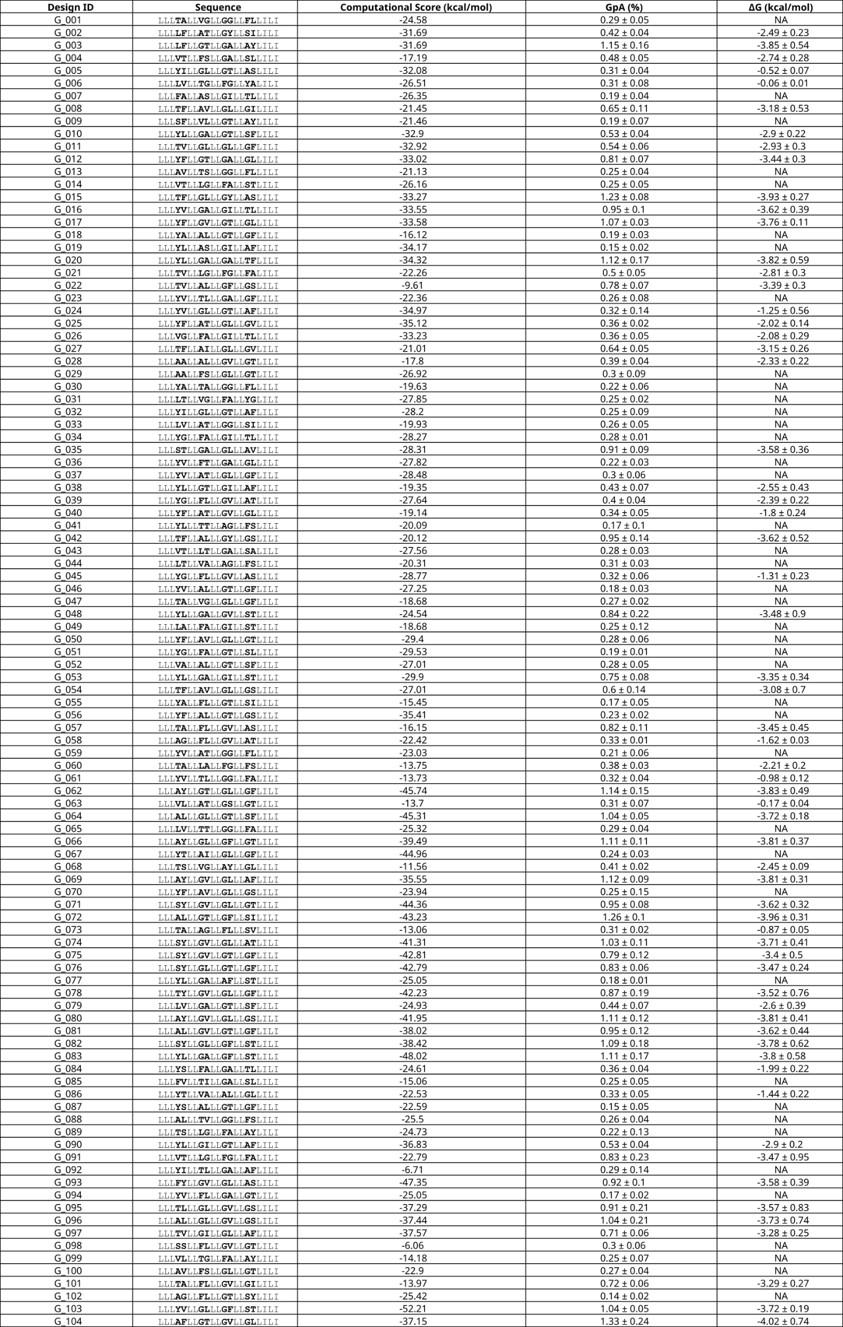**Table ST2.1 Validated set of GASright designs**



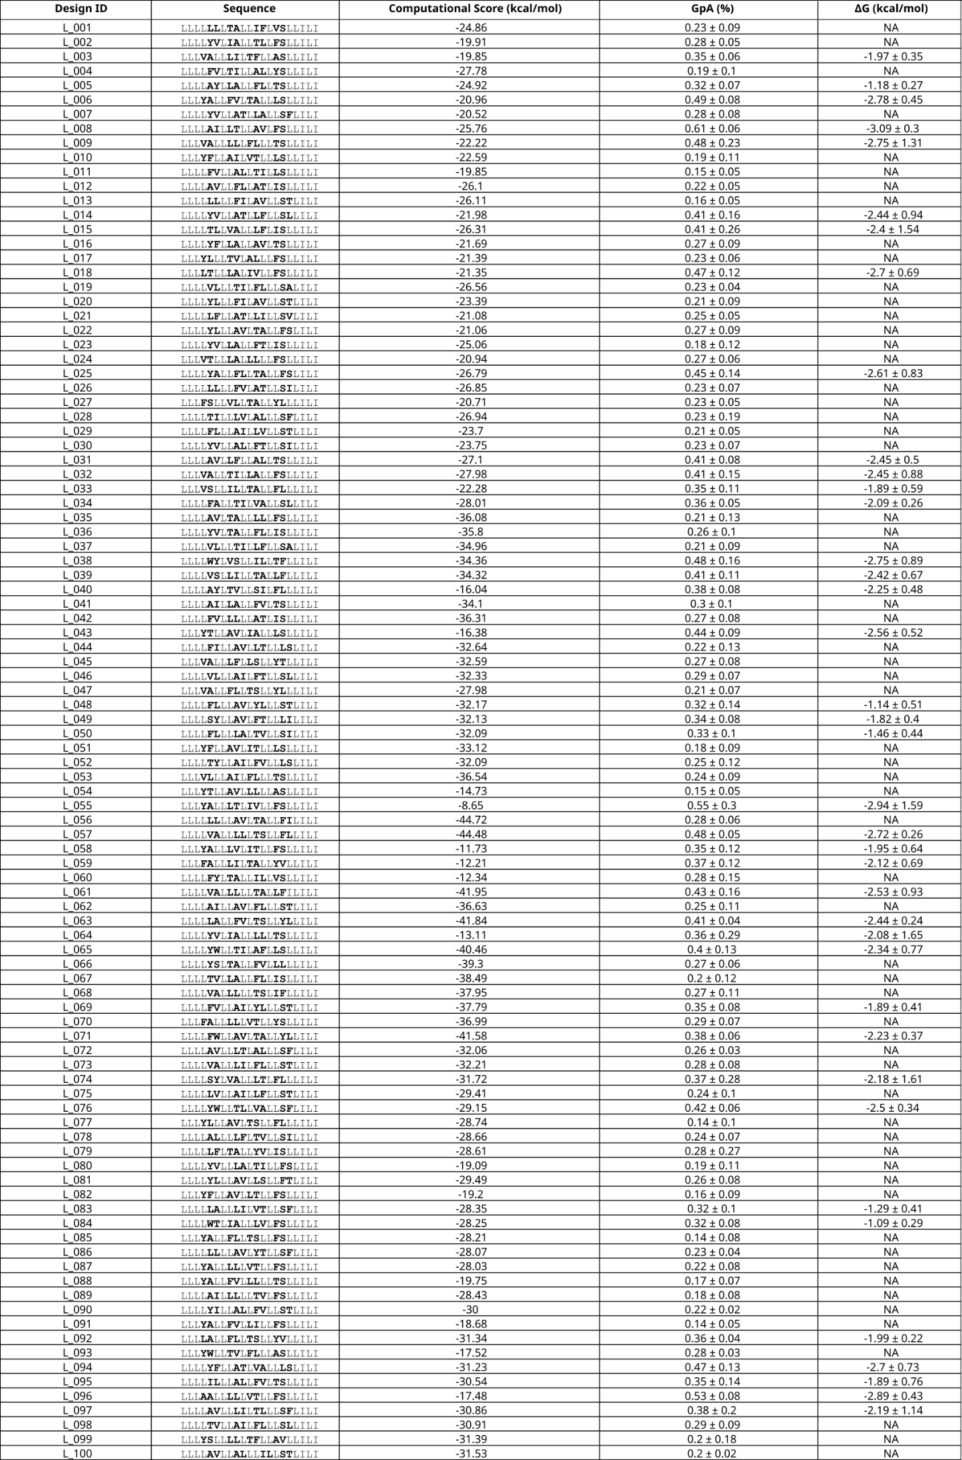**Table ST2.2 Validated set of Left designs**

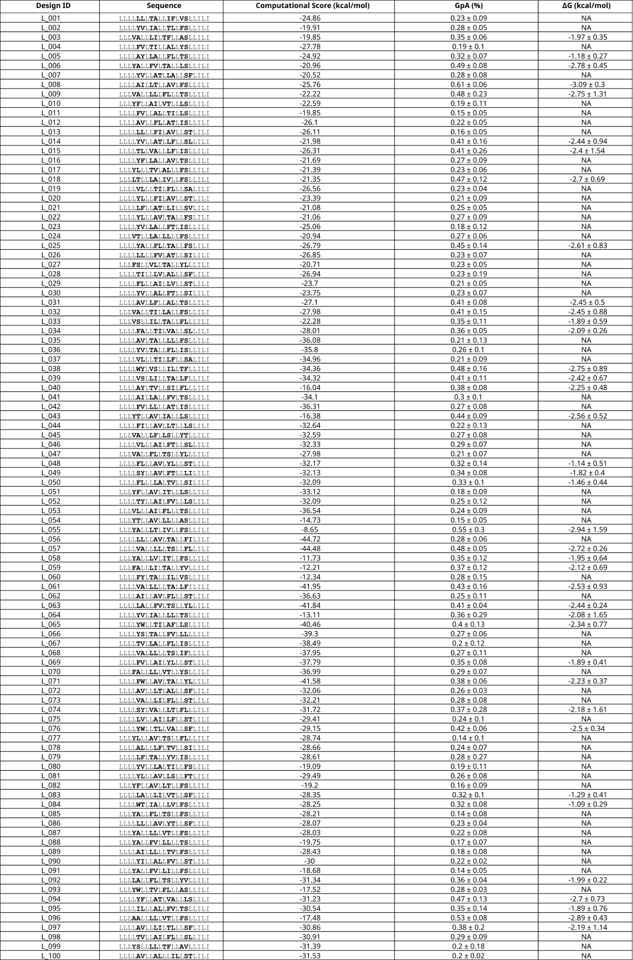

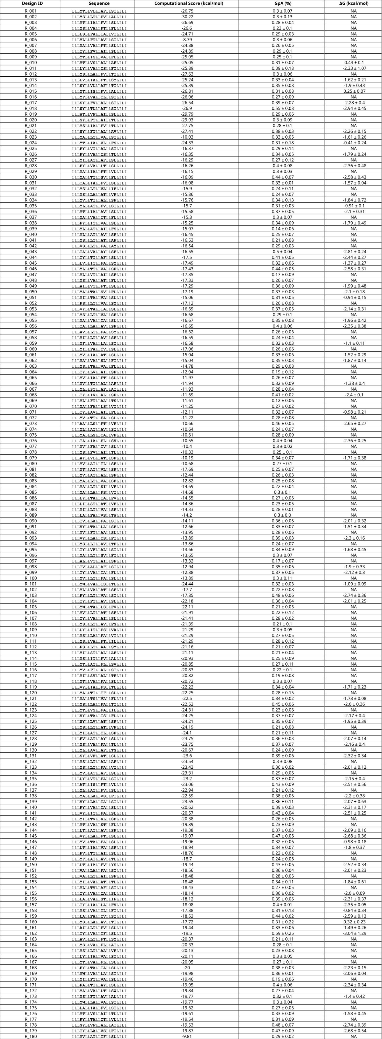**Table ST2.3 Validated set of Right designs**



****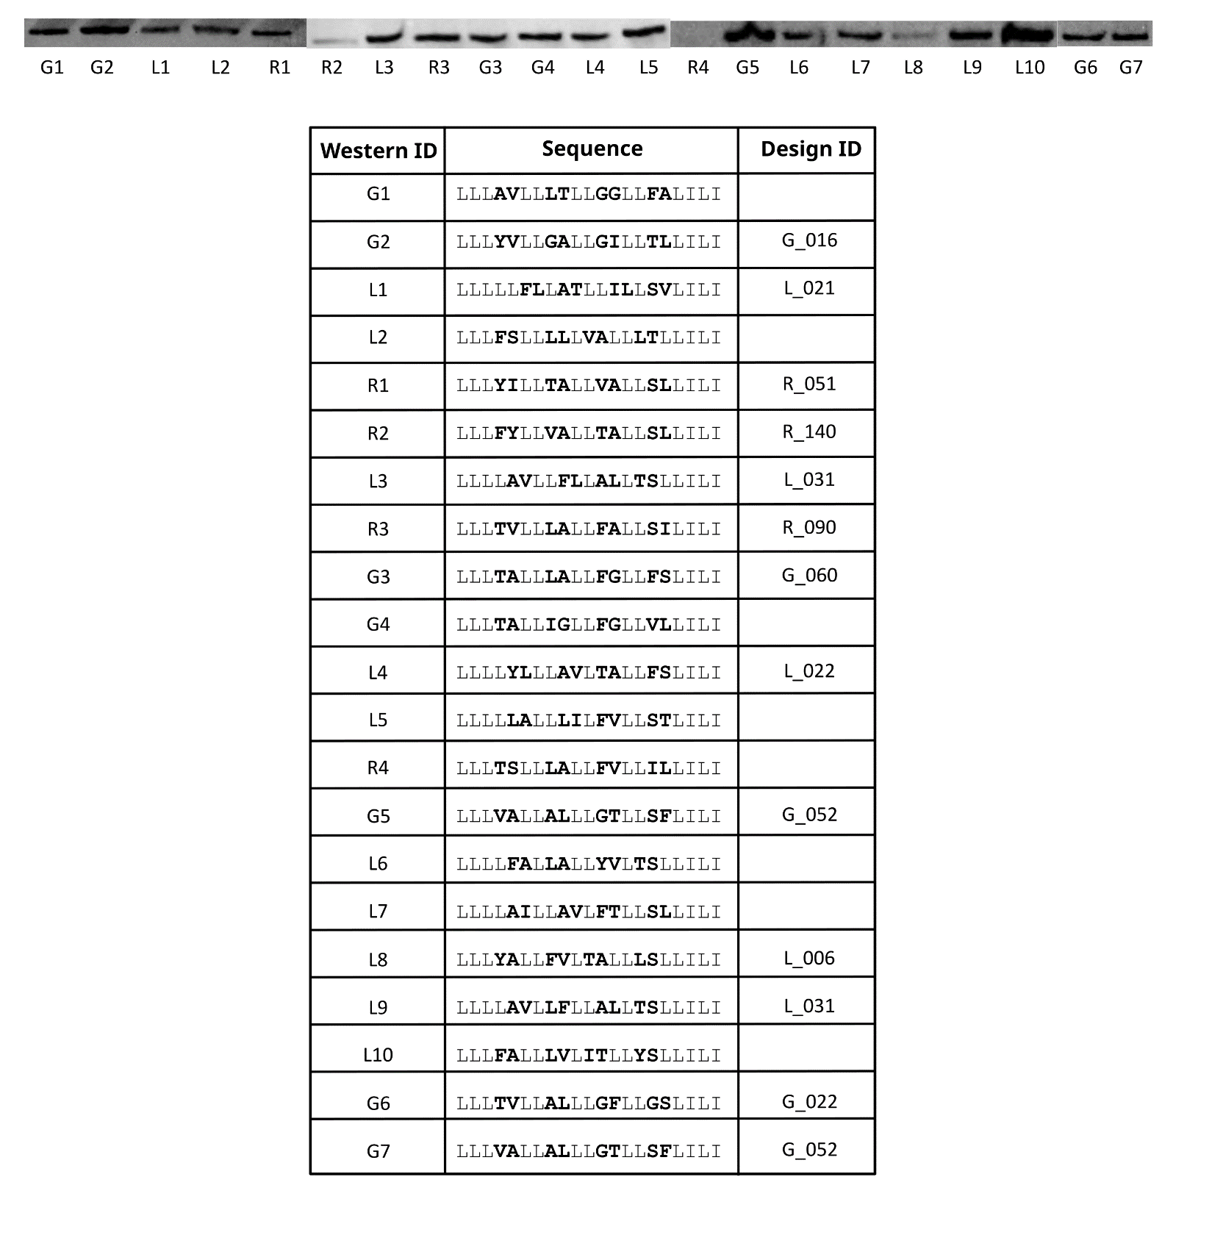

Data for validated sets of designs where clashing mutations < 35% GpA

Interfacial designed positions of each sequence in bold

Designs where a positive ΔG was calculated are designated NA

**Figure S2.1 Immunoblotting of designed constructs.** A subset of designed constructs were verified for their expression levels with western blots. While GASright and Left show similar levels of expression, Right designs often have fainter bands on western blots. Sequences without a Design ID are present in our sort-seq data but not part of our validated set (clashing mutants < 35% GpA)

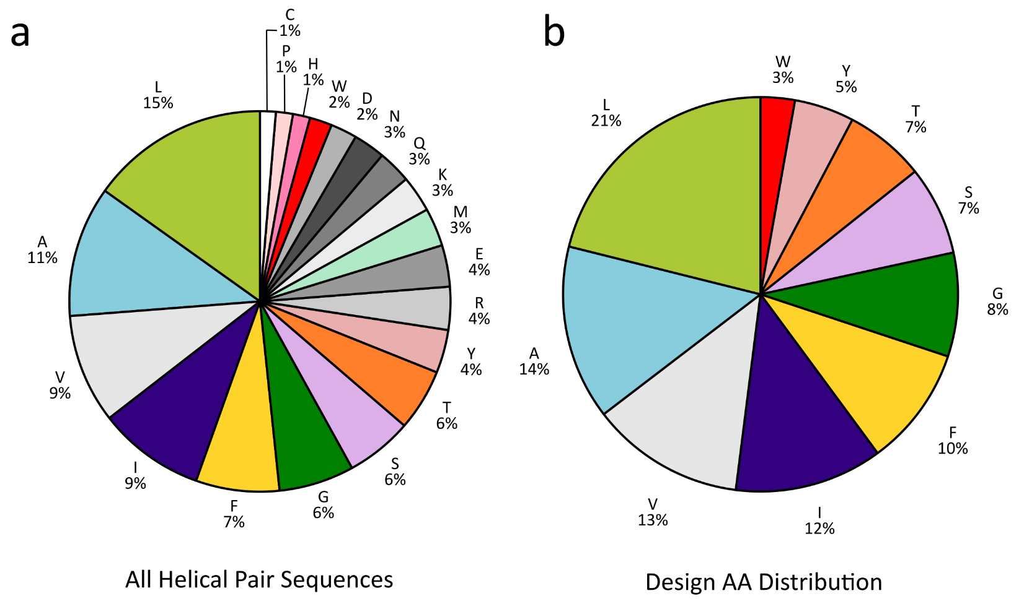

**Figure S2.2 Amino acid composition.** A) Frequency of amino acids from all transmembrane helical sequences extracted from OPM. B) The frequency of the design amino acids, adjusted to add up to 100% after removing the non-design amino acids. Sequences were designed with interfaces aiming to match the frequency of the design amino acid distribution (SEQUENCE_ENTROPY).

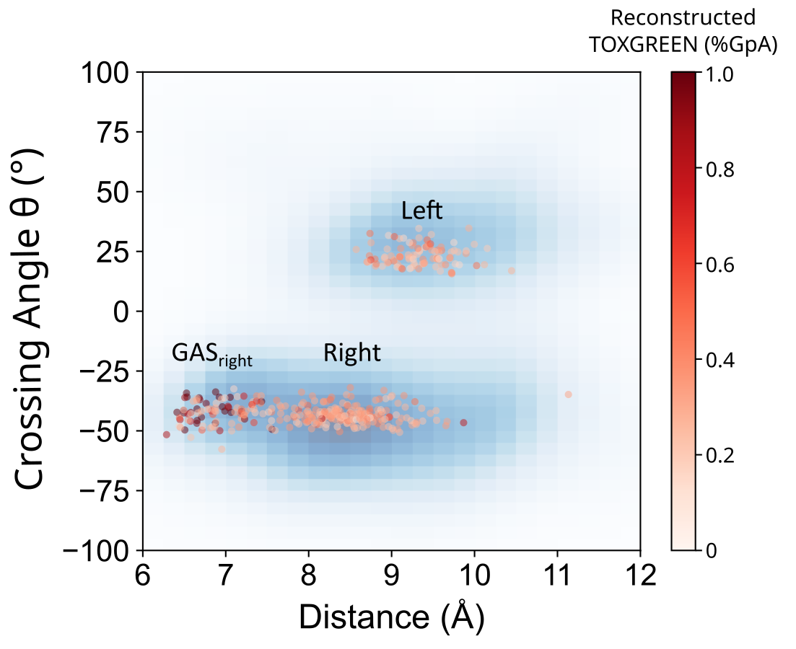

**Figure S2.3 Output Geometry vs Dimerization Propensity.** Distance and crossing angle of validated designed sequences plotted against %GpA in red. Sequences with highest dimerization propensity are dark red, most often found in GASright.

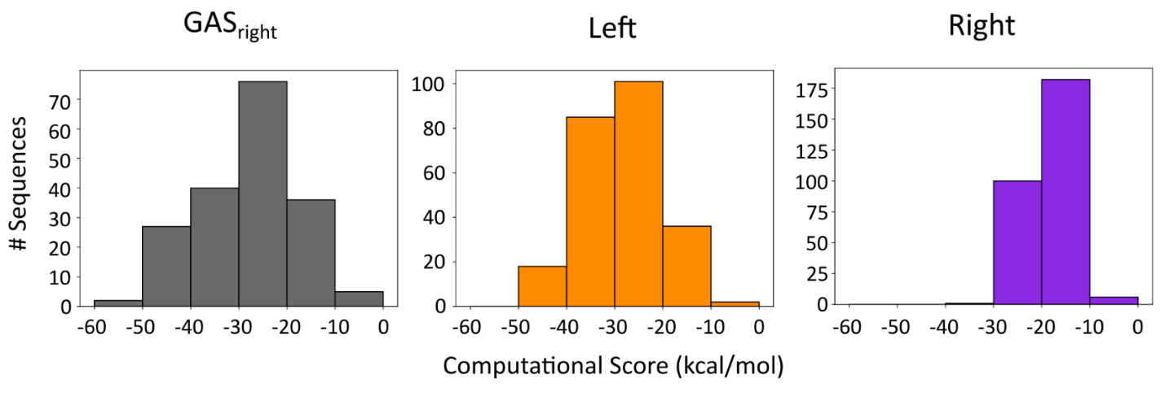

**Figure S2.4 Frequency of sequences by computational score.** Computationalenergy score of sequences present in sort-seq and the frequency for each design region.

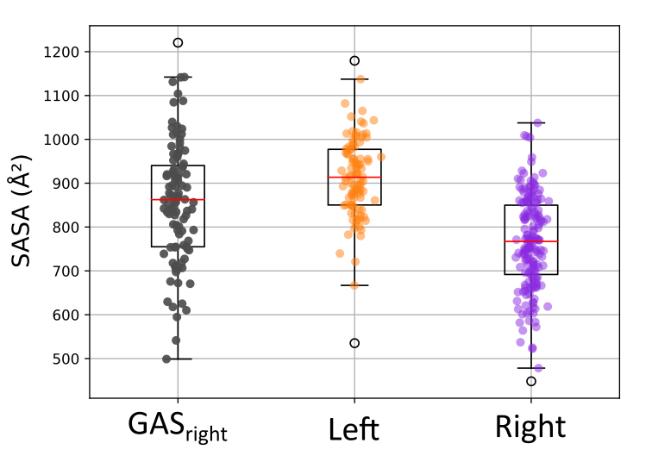

**Figure S2.5 Interface SASA.** Boxplots of calculated SASA at the interface of design structures of validated sequences. GASright and Left design interfaces are larger than Right, which may contribute to Right designs having a lower computational energy score.

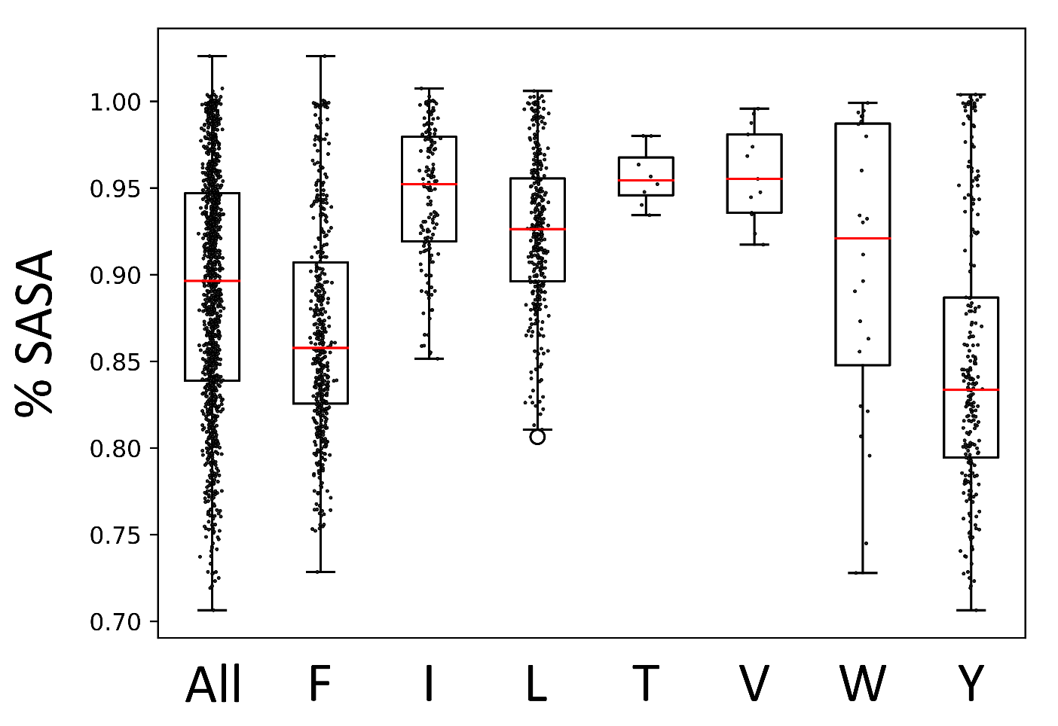

**Figure S2.6 % SASA of Large→Ala.** Single alanine point mutations were made on all interfacial positions designed structures. Mutants where the interface decreased the most, or the smallest % SASA (Design Interface SASA/Mutant Interface SASA **x** 100%), were selected.

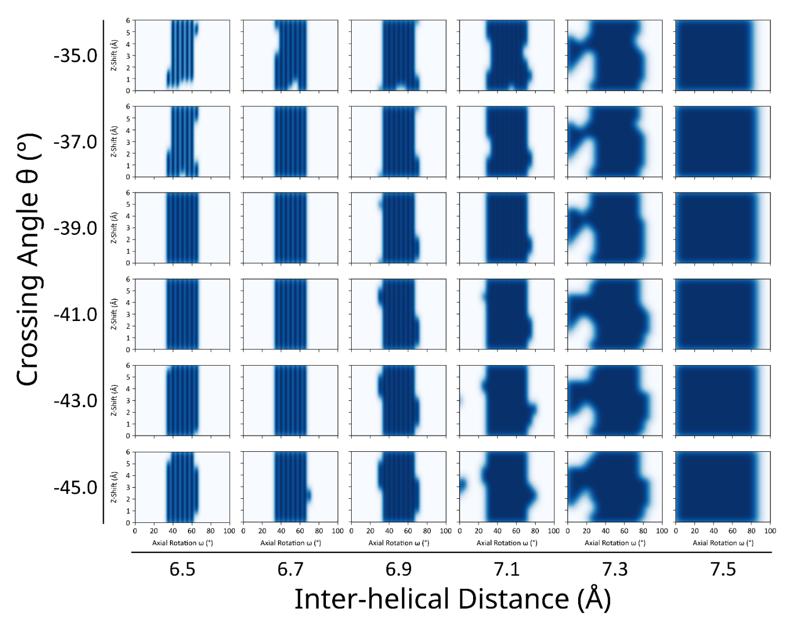

**Figure S2.7 GASright axial rotations and z-shifts.** A 4-dimensional grid of geometries were randomly generated to determine axial rotations and z-shifts for design. Poly-leucine helices with Ala at the design interface positions were placed at 3000 geometries and computational energy score measured. Geometries where energy score < 10 kcal/mol were plotted on a KDE plot of Z-Shift vs Axial Rotation. Values with KDE > 0.8 were randomly selected for design.

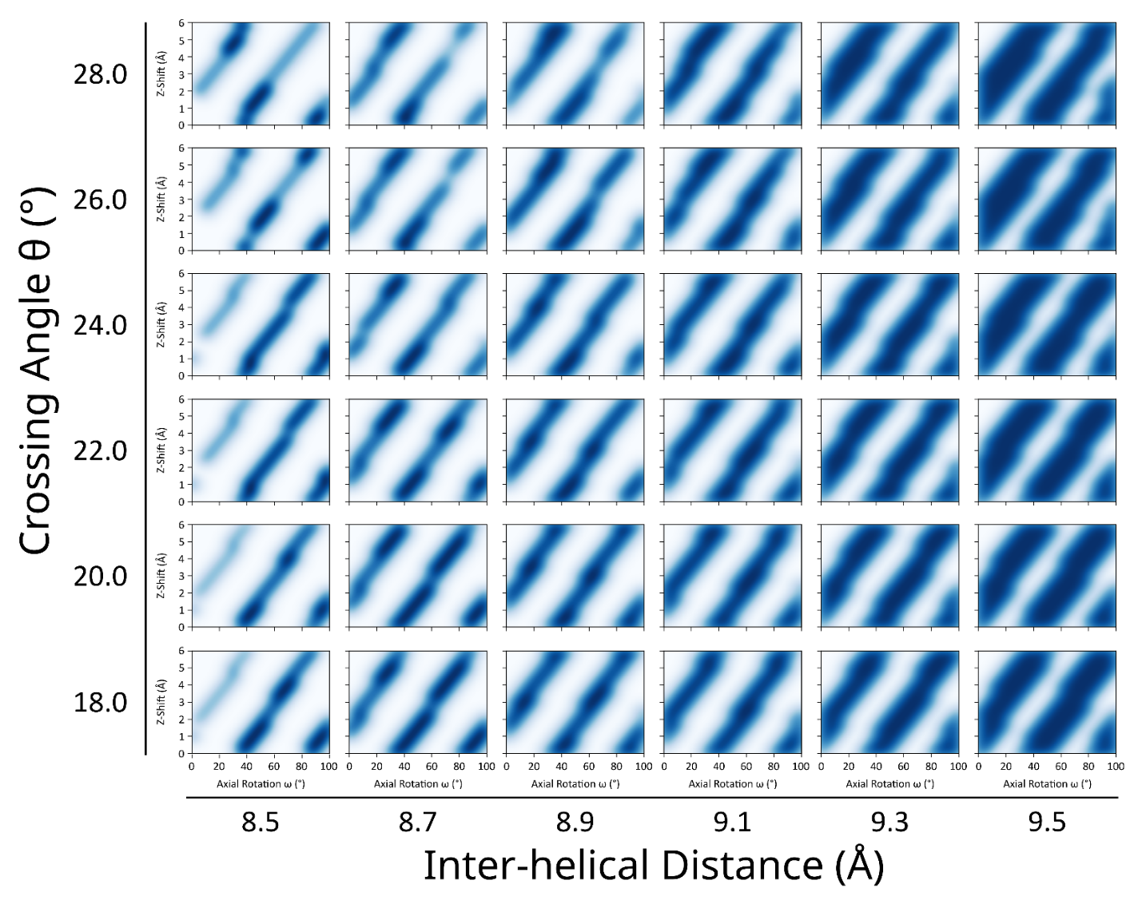

**Figure S2.8 Left axial rotations and z-shifts.** A 4-dimensional grid of geometries were randomly generated to determine axial rotations and z-shifts for design. Poly-leucine helices with Ala at the design interface positions were placed at 3000 geometries and computational energy score measured. Geometries where energy score < 10 kcal/mol were plotted on a KDE plot of Z-Shift vs Axial Rotation. Values with KDE > 0.8 were randomly selected for design.

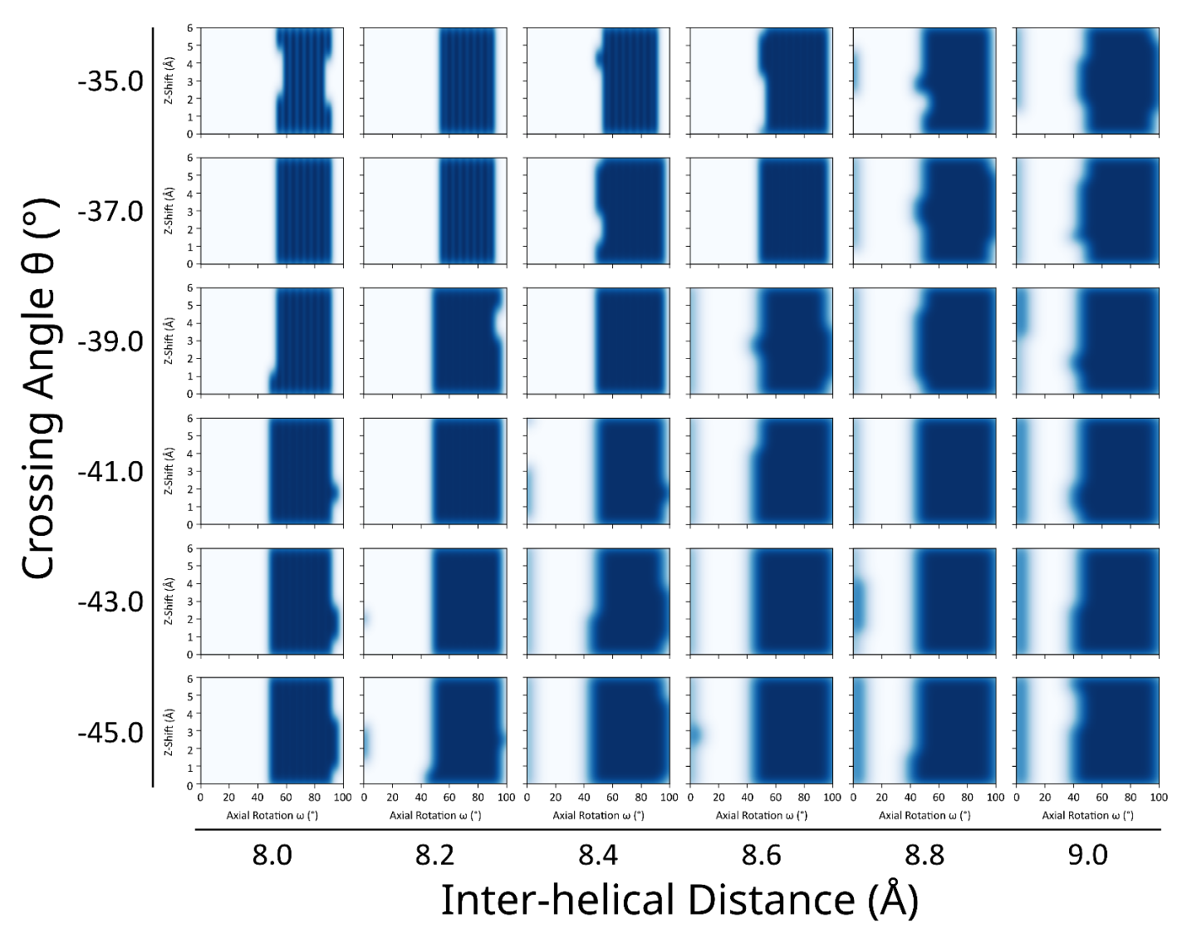

**Figure S2.9 Right axial rotations and z-shifts.** A 4-dimensional grid of geometries were randomly generated to determine axial rotations and z-shifts for design. Poly-leucine helices with Ala at the design interface positions were placed at 3000 geometries and computational energy score measured. Geometries where energy score < 10 kcal/mol were plotted on a KDE plot of Z-Shift vs Axial Rotation. Values with KDE > 0.8 were randomly selected for design.

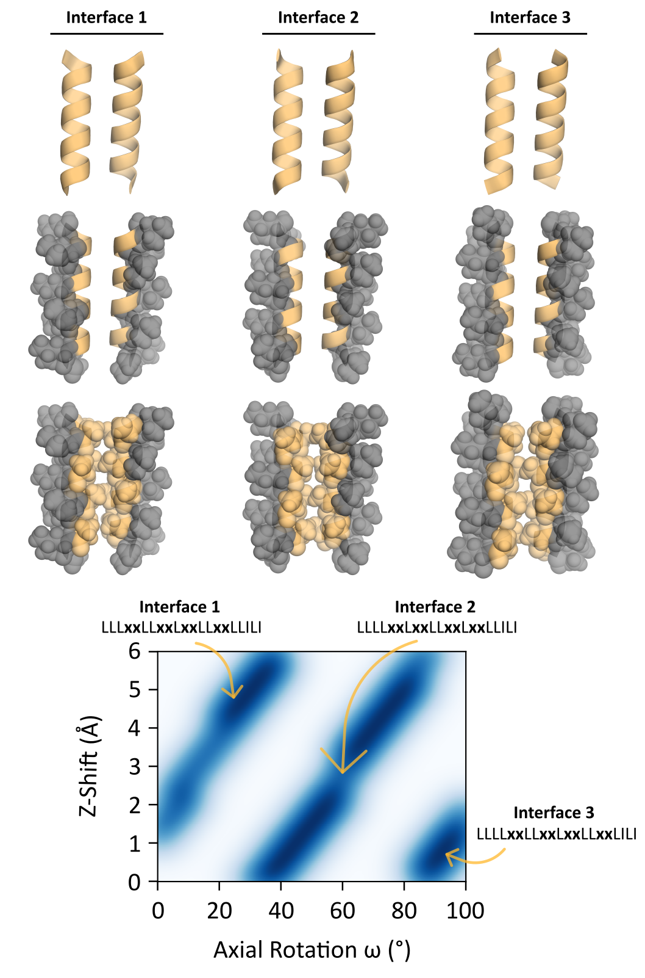

**Figure S2.10 Left-handed design interfaces.** Left-handed areas of high density were visually inspected to determine interfacial positions. Each design interface corresponds to a striped region of the axial rotation and z-shift density. Structures with Ala at corresponding interfacial positions are as visual representations.

2.7 References

Anderson, S. M. (2019). *Understanding the GASright Motif: Sequence, Structure, and Stability* [Ph.D., The University of Wisconsin - Madison]. https://www.proquest.com/docview/2331244818/abstract/2C4D47E16DE047ADPQ/1

Anderson, S. M., Mueller, B. K., Lange, E. J., & Senes, A. (2017). Combination of Cα-H Hydrogen Bonds and van der Waals Packing Modulates the Stability of GxxxG-Mediated Dimers in Membranes. *J Am Chem Soc*, *139*(44), 15774–15783. https://doi.org/10.1021/jacs.7b07505

Armstrong, C. R., & Senes, A. (2016). Screening for transmembrane association in divisome proteins using TOXGREEN, a high-throughput variant of the TOXCAT assay. *Biochim Biophys Acta*, *1858*(11), 2573–2583. https://doi.org/10.1016/j.bbamem.2016.07.008

Ash, W. L., Stockner, T., MacCallum, J. L., & Tieleman, D. P. (2004). Computer modeling of polyleucine-based coiled coil dimers in a realistic membrane environment: Insight into helix-helix interactions in membrane proteins. *Biochemistry*, *43*(28), 9050–9060. https://doi.org/10.1021/bi0494572

Ben-Tal, N., Sitkoff, D., Topol, I. A., Yang, A.-S., Burt, S. K., & Honig, B. (1997). Free energy of amide hydrogen bond formation in vacuum, in water, and in liquid alkane solution. *The Journal of Physical Chemistry B*, *101*(3), 450–457.

Bornberg-Bauer, E., Rivals, E., & Vingron, M. (1998). Computational approaches to identify leucine zippers. *Nucleic Acids Research*, *26*(11), 2740–2746. https://doi.org/10.1093/nar/26.11.2740

Bower, M. J., Cohen, F. E., & Dunbrack, R. L. (1997). Prediction of protein side-chain rotamers from a backbone-dependent rotamer library: A new homology modeling tool1. *Journal of Molecular Biology*, *267*(5), 1268–1282. https://doi.org/10.1006/jmbi.1997.0926

Bowie, J. U. (2011). Membrane protein folding: How important are hydrogen bonds? *Curr Opin Struct Biol*, *21*(1), 42–49. https://doi.org/10.1016/j.sbi.2010.10.003

Díaz Vázquez, G., Cui, Q., & Senes, A. (2023). Thermodynamic analysis of the GASright transmembrane motif supports energetic model of dimerization. *Biophysical Journal*, *122*(1), 143–155. https://doi.org/10.1016/j.bpj.2022.11.018

Doura, A. K., & Fleming, K. G. (2004). Complex Interactions at the Helix–Helix Interface Stabilize the Glycophorin A Transmembrane Dimer. *Journal of Molecular Biology*, *343*(5), 1487–1497. https://doi.org/10.1016/j.jmb.2004.09.011

Faham, S., Yang, D., Bare, E., Yohannan, S., Whitelegge, J. P., & Bowie, J. U. (2004). Side-chain contributions to membrane protein structure and stability. *J Mol Biol*, *335*(1), 297–305. https://doi.org/10.1016/j.jmb.2003.10.041

Fleming, K. G., & Engelman, D. M. (2001). Computation and mutagenesis suggest a right-handed structure for the synaptobrevin transmembrane dimer. *Proteins: Structure, Function, and Bioinformatics*, *45*(4), 313–317. https://doi.org/10.1002/prot.1151

Gregersen, N., Bross, P., Vang, S., & Christensen, J. H. (2006). Protein misfolding and human disease. *Annu Rev Genomics Hum Genet*, *7*, 103–124. https://doi.org/10.1146/annurev.genom.7.080505.115737

Howitt, S. M., Rodgers, A. J. W., Jeffrey, P. D., & Cox, G. B. (1996). A Mutation in Which Alanine 128 Is Replaced by Aspartic Acid Abolishes Dimerization of the b-Subunit of the F0F1-ATPase from Escherichia coli(∗). *Journal of Biological Chemistry*, *271*(12), 7038–7042. https://doi.org/10.1074/jbc.271.12.7038

Huang, B., Xu, Y., Hu, X., Liu, Y., Liao, S., Zhang, J., Huang, C., Hong, J., Chen, Q., & Liu, H. (2022). A backbone-centred energy function of neural networks for protein design. *Nature*, *602*(7897), Article 7897. https://doi.org/10.1038/s41586-021-04383-5

Joh, N. H., Oberai, A., Yang, D., Whitelegge, J. P., & Bowie, J. U. (2009). Similar energetic contributions of packing in the core of membrane and water-soluble proteins. *J Am Chem Soc*, *131*(31), 10846–10847. https://doi.org/10.1021/ja904711k

Johnson, R. M., Hecht, K., & Deber, C. M. (2007). Aromatic and cation-pi interactions enhance helix-helix association in a membrane environment. *Biochemistry*, *46*(32), 9208–9214. https://doi.org/10.1021/bi7008773

Khadria, A. S., Mueller, B. K., Stefely, J. A., Tan, C. H., Pagliarini, D. J., & Senes, A. (2014). A Gly-Zipper Motif Mediates Homodimerization of the Transmembrane Domain of the Mitochondrial Kinase ADCK3. *Journal of the American Chemical Society*, *136*(40), 14068–14077. https://doi.org/10.1021/ja505017f

Krivov, G. G., Shapovalov, M. V., & Dunbrack, R. L. (2009). Improved prediction of protein side-chain conformations with SCWRL4. *Proteins*, *77*(4), 778–795. https://doi.org/10.1002/prot.22488

Kuhlman, B., Dantas, G., Ireton, G. C., Varani, G., Stoddard, B. L., & Baker, D. (2003). Design of a Novel Globular Protein Fold with Atomic-Level Accuracy. *Science*, *302*(5649), 1364–1368. https://doi.org/10.1126/science.1089427

Kulp, D. W., Subramaniam, S., Donald, J. E., Hannigan, B. T., Mueller, B. K., Grigoryan, G., & Senes, A. (2012). Structural informatics, modeling, and design with an open-source Molecular Software Library (MSL). *J Comput Chem*, *33*(20), 1645–1661. https://doi.org/10.1002/jcc.22968

LaPointe, L. M., Taylor, K. C., Subramaniam, S., Khadria, A., Rayment, I., & Senes, A. (2013). Structural Organization of FtsB, a Transmembrane Protein of the Bacterial Divisome. *Biochemistry*, *52*(15), 2574–2585. https://doi.org/10.1021/bi400222r

Lawrie, C. M., Sulistijo, E. S., & MacKenzie, K. R. (2010). Intermonomer Hydrogen Bonds Enhance GxxxG-Driven Dimerization of the BNIP3 Transmembrane Domain: Roles for Sequence Context in Helix–Helix Association in Membranes. *Journal of Molecular Biology*, *396*(4), 924–936. https://doi.org/10.1016/j.jmb.2009.12.023

Lazaridis, T. (2003). Effective energy function for proteins in lipid membranes. *Proteins*, *52*(2), 176–192. https://doi.org/10.1002/prot.10410

Liang, B., & Tamm, L. K. (2016). NMR as a tool to investigate the structure, dynamics and function of membrane proteins. *Nat Struct Mol Biol*, *23*(6), 468–474. https://doi.org/10.1038/nsmb.3226

Liu, Y., Engelman, D. M., & Gerstein, M. (2002). Genomic analysis of membrane protein families: Abundance and conserved motifs. *Genome Biol*, *3*(10), research0054. https://doi.org/10.1186/gb-2002-3-10-research0054

Lomize, M. A., Lomize, A. L., Pogozheva, I. D., & Mosberg, H. I. (2006). OPM: orientations of proteins in membranes database. *Bioinformatics*, *22*(5), 623–625.

MacKenzie, K. R., Prestegard, J. H., & Engelman, D. M. (1997). A transmembrane helix dimer: Structure and implications. *Science*, *276*(5309), 131–133. https://doi.org/10.1126/science.276.5309.131

MacKerell, A. D., Bashford, D., Bellott, M., Dunbrack, R. L., Evanseck, J. D., Field, M. J., Fischer, S., Gao, J., Guo, H., Ha, S., Joseph-McCarthy, D., Kuchnir, L., Kuczera, K., Lau, F. T., Mattos, C., Michnick, S., Ngo, T., Nguyen, D. T., Prodhom, B., … Karplus, M. (1998). All-atom empirical potential for molecular modeling and dynamics studies of proteins. *J Phys Chem B*, *102*(18), 3586–3616. https://doi.org/10.1021/jp973084f

Metcalf, D. G., Law, P. B., & DeGrado, W. F. (2007). Mutagenesis data in the automated prediction of transmembrane helix dimers. *Proteins: Structure, Function, and Bioinformatics*, *67*(2), 375–384. https://doi.org/10.1002/prot.21265

Mingarro, I., Whitley, P., Heijne, G. V., & Lemmon, M. A. (1996). Ala-insertion scanning mutagenesis of the glycophorin a transmembrane helix: A rapid way to map helix-helix interactions in integral membrane proteins. *Protein Science*, *5*(7), 1339–1341. https://doi.org/10.1002/pro.5560050712

Mitchell, J. B., & Price, S. L. (1990). The nature of the NH… ︁O=C hydrogen bond: An intermolecular perturbation theory study of the formamide/formaldehyde complex. *Journal of Computational Chemistry*, *11*(10), 1217–1233.

Mravic, M., Thomaston, J. L., Tucker, M., Solomon, P. E., Liu, L., & DeGrado, W. F. (2019). Packing of apolar side chains enables accurate design of highly stable membrane proteins. *Science*, *363*(6434), 1418–1423. https://doi.org/10.1126/science.aav7541

Mueller, B. K., Subramaniam, S., & Senes, A. (2014). A frequent, GxxxG-mediated, transmembrane association motif is optimized for the formation of interhelical Cα-H hydrogen bonds. *Proc Natl Acad Sci U S A*, *111*(10), E888-95. https://doi.org/10.1073/pnas.1319944111

Nash, A., Notman, R., & Dixon, A. M. (2015). De novo design of transmembrane helix-helix interactions and measurement of stability in a biological membrane. *Biochim Biophys Acta*, *1848*(5), 1248–1257. https://doi.org/10.1016/j.bbamem.2015.02.020

Partridge, A. W., Therien, A. G., & Deber, C. M. (2004). Missense mutations in transmembrane domains of proteins: Phenotypic propensity of polar residues for human disease. *Proteins*, *54*(4), 648–656. https://doi.org/10.1002/prot.10611

Rose, G. D., & Wolfenden, R. (1993). Hydrogen bonding, hydrophobicity, packing, and protein folding. *Annual Review of Biophysics and Biomolecular Structure*, *22*(1), 381–415.

Russ, W. P., & Engelman, D. M. (2000). The GxxxG motif: A framework for transmembrane helix-helix association. *J Mol Biol*, *296*(3), 911–919. https://doi.org/10.1006/jmbi.1999.3489

Sanders, C. R., & Myers, J. K. (2004). Disease-related misassembly of membrane proteins. *Annu Rev Biophys Biomol Struct*, *33*, 25–51. https://doi.org/10.1146/annurev.biophys.33.110502.140348

Senes, A. (2011). Computational design of membrane proteins. *Curr Opin Struct Biol*, *21*(4), 460–466. https://doi.org/10.1016/j.sbi.2011.06.004

Senes, A., Ubarretxena-Belandia, I., & Engelman, D. M. (2001). The Cα—H⋅⋅⋅O hydrogen bond: A determinant of stability and specificity in transmembrane helix interactions. *Proceedings of the National Academy of Sciences*, *98*(16), 9056–9061. https://doi.org/10.1073/pnas.161280798

Smith, S. O., Eilers, M., Song, D., Crocker, E., Ying, W., Groesbeek, M., Metz, G., Ziliox, M., & Aimoto, S. (2002). Implications of threonine hydrogen bonding in the glycophorin A transmembrane helix dimer. *Biophys J*, *82*(5), 2476–2486. https://doi.org/10.1016/S0006-3495(02)75590-2

Steinegger, M., & Söding, J. (2017). MMseqs2 enables sensitive protein sequence searching for the analysis of massive data sets. *Nature Biotechnology*, *35*(11), 1026–1028.

Subramaniam, S., & Senes, A. (2012). An energy-based conformer library for side chain optimization: Improved prediction and adjustable sampling. *Proteins*, *80*(9), 2218–2234. https://doi.org/10.1002/prot.24111

Therien, A. G., Grant, F. E., & Deber, C. M. (2001). Interhelical hydrogen bonds in the CFTR membrane domain. *Nat Struct Biol*, *8*(7), 597–601. https://doi.org/10.1038/89631

Tsemekhman, K., Goldschmidt, L., Eisenberg, D., & Baker, D. (2007). Cooperative hydrogen bonding in amyloid formation. *Protein Science*, *16*(4), 761–764.

Walshaw, J., & Woolfson, D. N. (2003). Extended knobs-into-holes packing in classical and complex coiled-coil assemblies. *Journal of Structural Biology*, *144*(3), 349–361.

Walters, R. F. S., & DeGrado, W. F. (2006). Helix-packing motifs in membrane proteins. *Proceedings of the National Academy of Sciences*, *103*(37), 13658–13663. https://doi.org/10.1073/pnas.0605878103

Wehbi, H., Gasmi-Seabrook, G., Choi, M. Y., & Deber, C. M. (2008). Positional dependence of non-native polar mutations on folding of CFTR helical hairpins. *Biochim Biophys Acta*, *1778*(1), 79–87. https://doi.org/10.1016/j.bbamem.2007.08.036

Wei, P., Liu, X., Hu, M.-H., Zuo, L.-M., Kai, M., Wang, R., & Luo, S.-Z. (2011). The dimerization interface of the glycoprotein Ibβ transmembrane domain corresponds to polar residues within a leucine zipper motif. *Protein Science*, *20*(11), 1814–1823. https://doi.org/10.1002/pro.713

Wei, P., Zheng, B.-K., Guo, P.-R., Kawakami, T., & Luo, S.-Z. (2013). The Association of Polar Residues in the DAP12 homodimer: TOXCAT and Molecular Dynamics Simulation Studies. *Biophysical Journal*, *104*(7), 1435–1444. https://doi.org/10.1016/j.bpj.2013.01.054

Yano, Y., Takemoto, T., Kobayashi, S., Yasui, H., Sakurai, H., Ohashi, W., Niwa, M., Futaki, S., Sugiura, Y., & Matsuzaki, K. (2002). Topological stability and self-association of a completely hydrophobic model transmembrane helix in lipid bilayers. *Biochemistry*, *41*(9), 3073–3080. https://doi.org/10.1021/bi011161y

Zhou, F. X., Merianos, H. J., Brunger, A. T., & Engelman, D. M. (2001). Polar residues drive association of polyleucine transmembrane helices. *Proc Natl Acad Sci U S A*, *98*(5), 2250–2255. https://doi.org/10.1073/pnas.041593698